1.
AirDroid
Let’s say you want to connect your droid to a PC, but you’re unable (or too lazy) to find your USB cable. AirDroid lets your PC access the contents of your phone using nothing but a web browser. Here’s how it works:
When opened, the app provides an IP address and a password. Your phone and PC should be on the same wi-fi connection. Feed the address into any web browser (though IE isn’t recommended). Login by giving the password and now you have access to your gallery, contacts, apps, call logs and messages. Further, you can install and uninstall apps, send and receive texts and kill active processes in real time, all this over-the-air.

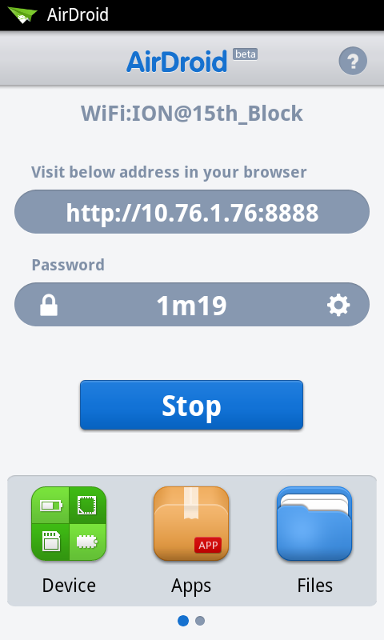
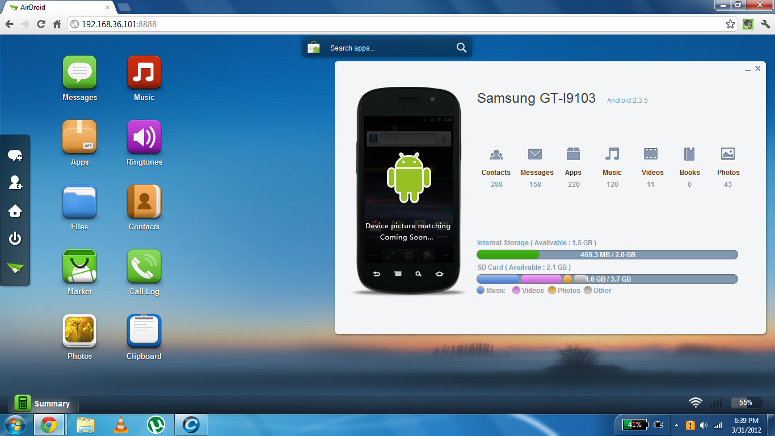

Quick wireless connectivity, simple operation and slick UI make this app a must have amongst all droid owners.

2.
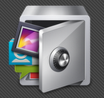 APP Lock
APP Lock enables you to lock applications of your choice with a password or pattern. This way you can protect personal accounts such as e-mail and facebook, along with any other apps you please without having to lock up apps (like games) which you wish to share with your friends. The interface is great – keeping things neat and simple. However, it sometimes shows a glimpse of the locked app before asking for the password. This is a small flaw in an otherwise impressive app.

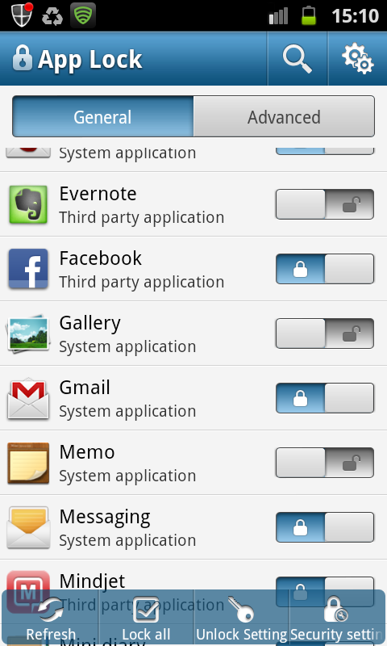
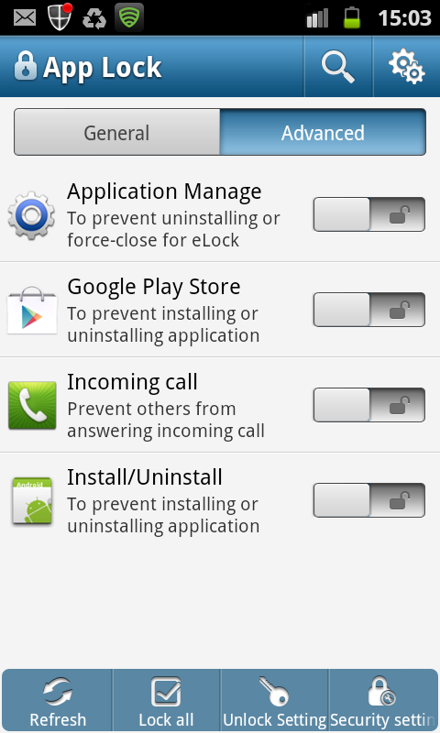
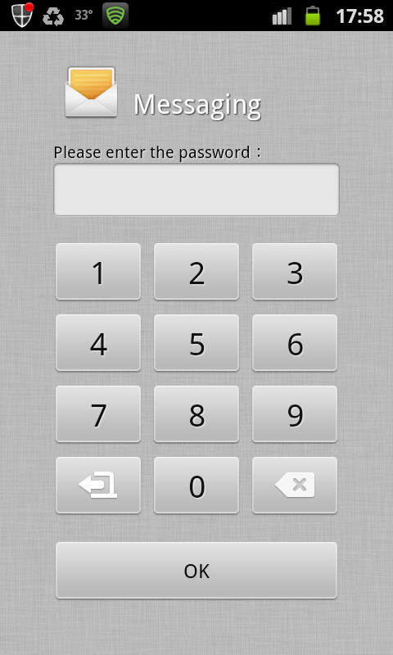
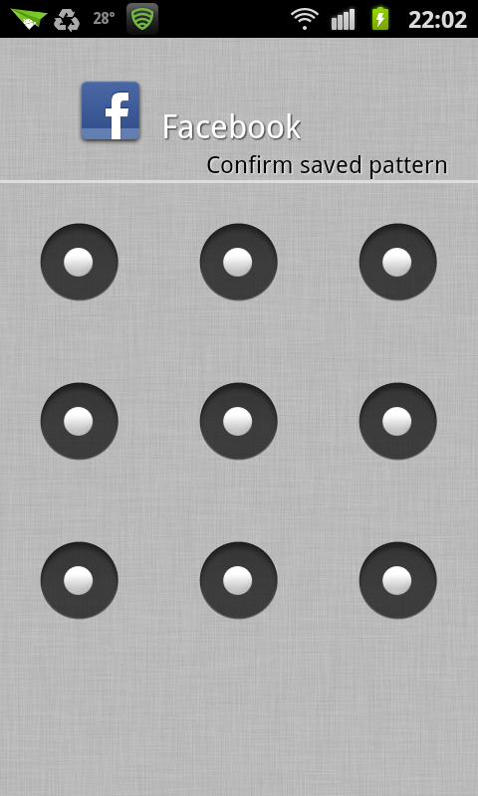
3.
Lookout
Lookout single-handidly takes care of the anti-virus needs of your smartphone. It blocks malware, spyware and trojans. Lookout scans new apps as soon as they are installed on the system. Regular scans can be scheduled as per your convenience. Lookout also provides tracking services in case your phone gets lost. By logging into www.mylookout.com you can track your phone on a google map even if GPS is turned off. You can also sound an alarm on the device even if it’s on silent mode. Lookout automatically backs up your contacts which can then be restored at any time. Lookout is another must have app as mobile security doesn’t get better than this.
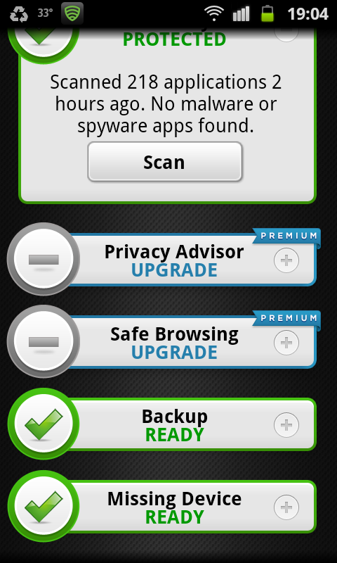
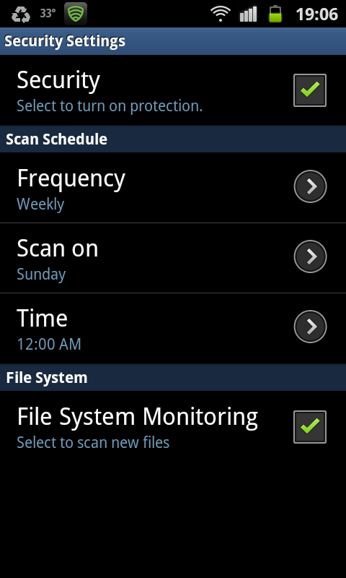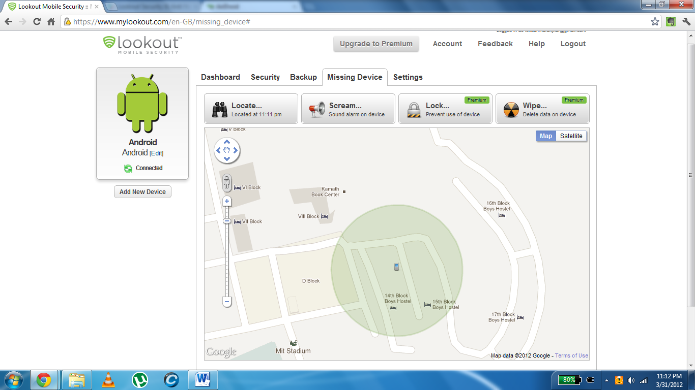
4.
 Read It Later
Read It Later lets you save web pages, articles and videos for viewing offline. RIL downloads articles in a webpage or the entire webpage itself exactly the way they are, except for flash content. The result is beautifully formatted text and images. It supports text reflow for convenient reading. You can adjust the text size, font, alignment and darkness for night-time reading.
It gives you the option of tagging your articles so that they can be sorted and searched for later on. It even remembers your scroll position so you can start reading exactly where you left off.
RIL is sure to interest you with an article when you find yourself without an internet connection.
